Contributor: Betsie van der Westhuizen
Entry: Van Heerden, Ernst (1916-1997)
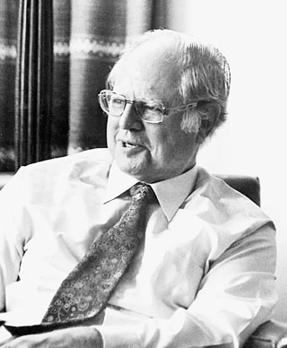
Ernst van Heerden is one of the most prominent South African poets of the 20th century. He was born in the Karoo town of Pearston and studied at the University of Stellenbosch. He journeyed before and after World War II to Europe and the USA, during which time he broadened and deepened his knowledge of world literatures. He became acquainted with, amongst others, the poetry of the Modernists, which had a profound influence on his own views on the arts, his own writing and his critical work. He was a professor of Afrikaans and Dutch literature at the University of the Witwatersrand (Wits). Emanating from his own participation in weightlifting, sport features prominently in his poetic oeuvre. Other significant themes are the environment, nature, war, confinement, entanglement, incarceration, fear, mental and physical endurance, patterns of time, mortality and death. He was a writer and poet with an acute awareness of language, and experimented with images, words, sound and form, often in a synesthetic way so that the lived experience in his poems can also be seen, felt, and heard simultaneously in multiple ways, infusing an expansion of meaning and emotional weight. He published fifteen volumes of poetry, of which Die Weerlose Uur (The Defenseless Hour) (1942), was his debut and Die Herfstelike Lig (The Autumnal Light) (1996), was the last. He also published two travel books, two biographical works, and four volumes of critical essays. A volume of twenty nine sports poems in his own handwriting was published under the title Sportgedigte (Sports Poems) by the Sportburo of the University of Pretoria on the occasion of Van Heerden’s seventieth birthday.
http://tinyurl.com/dy77zc7

For the Olympic Arts Competition, which coincided with the Olympic Games of 1948, held in London, he won a silver medal for his entry, Ses Gedigte (Six Poems), poems in Afrikaans with summaries in English. The language and the arrangement of stanzas of these poems reflect the nature of the sports they depict, including the taut, abrupt movements of weightlifting.
References and further reading
Malan, Lucas. (1999) ‘Ernst van Heerden (1916-1997)’, In Van Coller, H.P. ed. Perspektief en Profiel, Deel 2 (Perspective and Profile, Volume 2: 671-678), Pretoria: J.L. van Schaik.. (A literary historical discussion of the oeuvre of Ernst van Heerden.)
Van Heerden, Ernst. (1977) Digterlike Diagnose (Poetical Diagnosis), Kaapstad: Tafelberg. (In the essay ‘The Language of the Poet’ Van Heerden refers to the views and work of numerous poets, in a way that identifies him with the Modernists of the 20th century.)

